**WEEK 2 OUTPUTS:**

**Exercise 1: Control Structures**

**Scenario 1:**

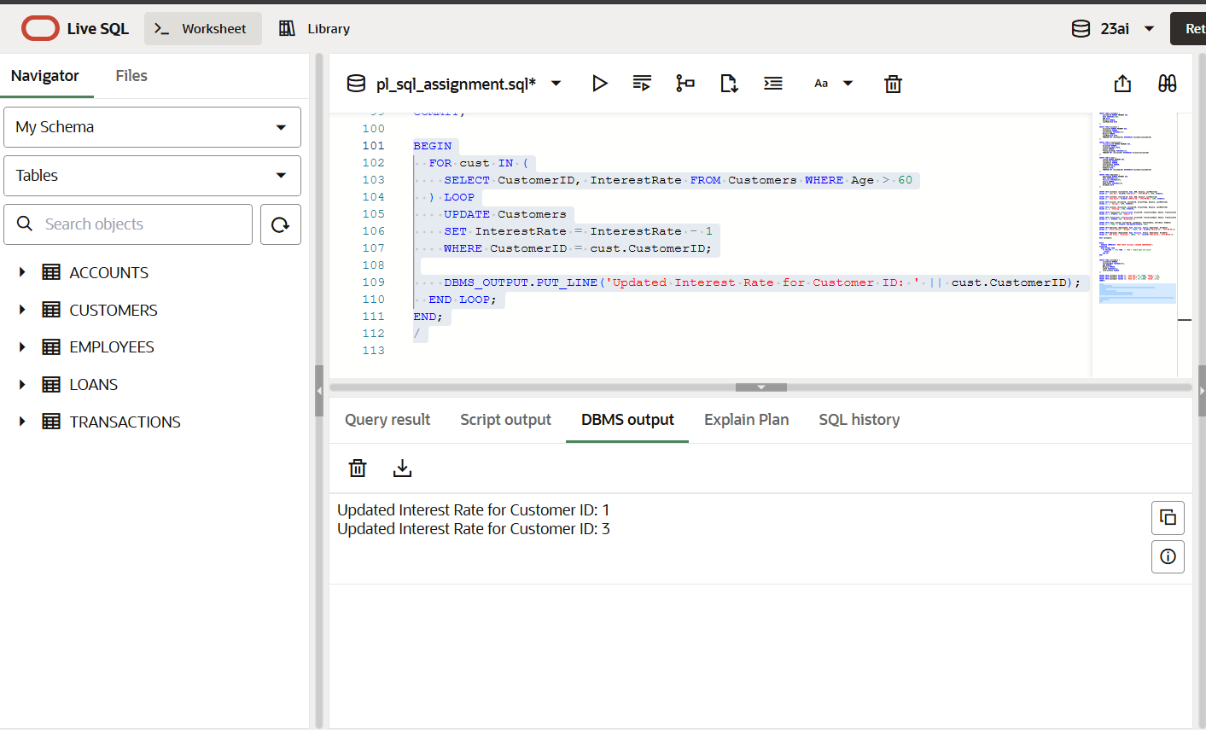

**Scenario 2:**

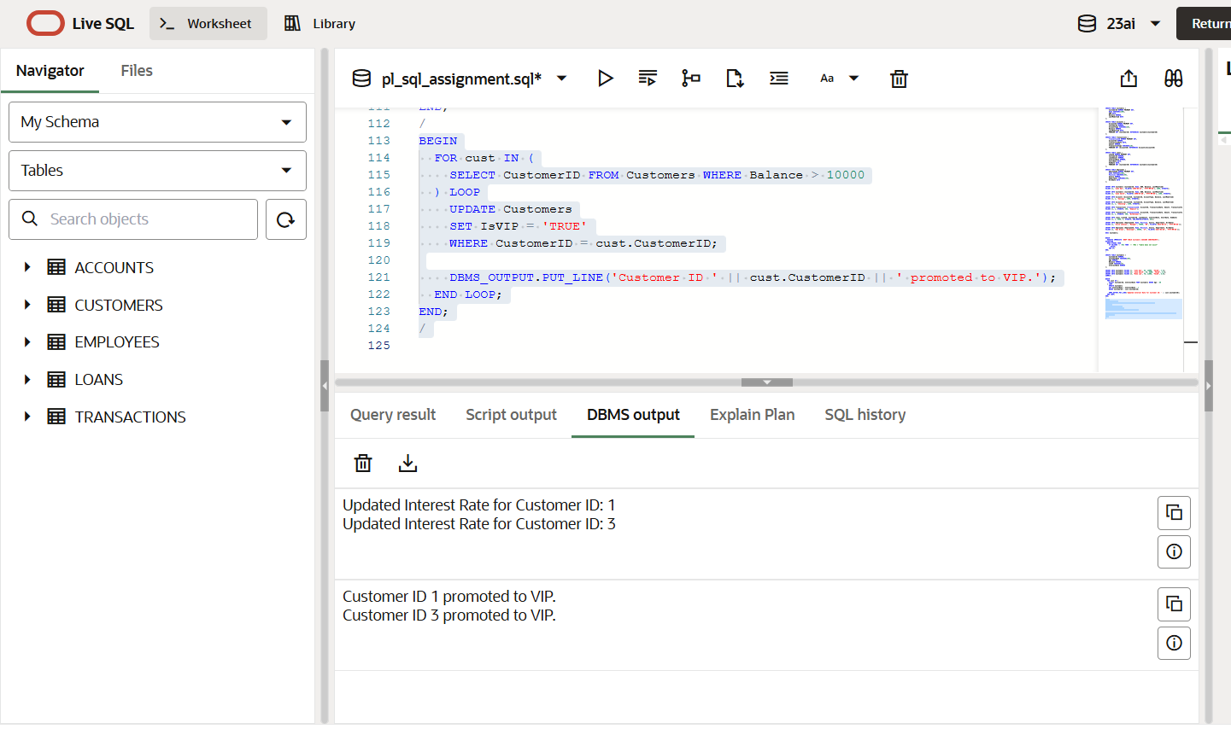

**Scenario 3:**

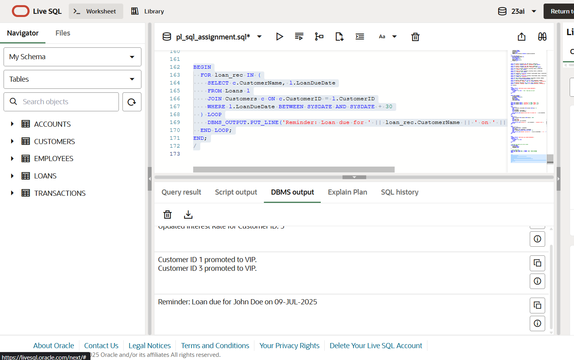

**Exercise 3: Stored Procedures**

**Scenario 1: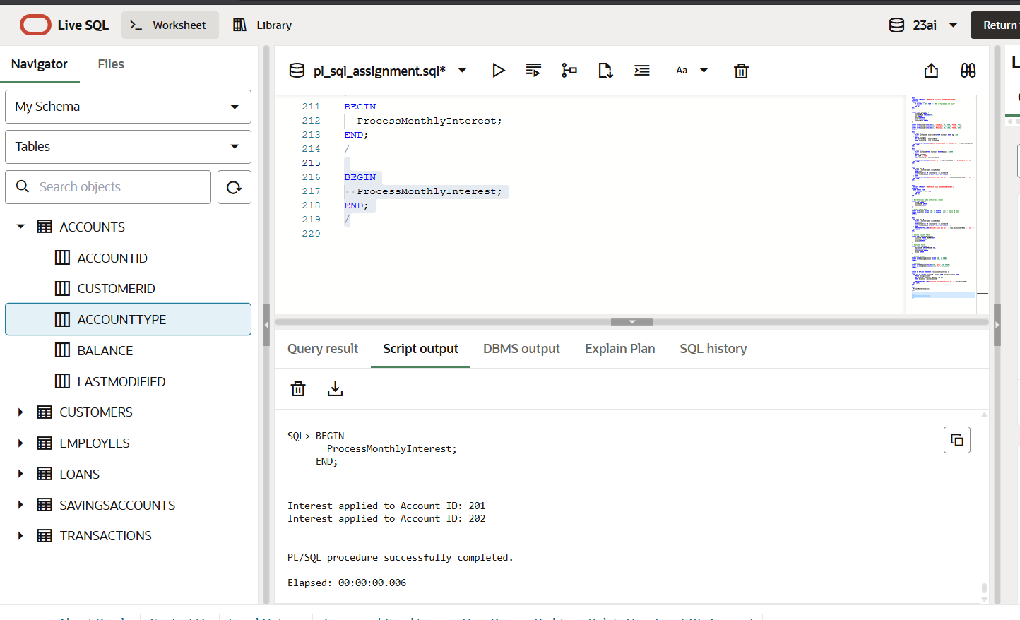 Scenario 2:**

**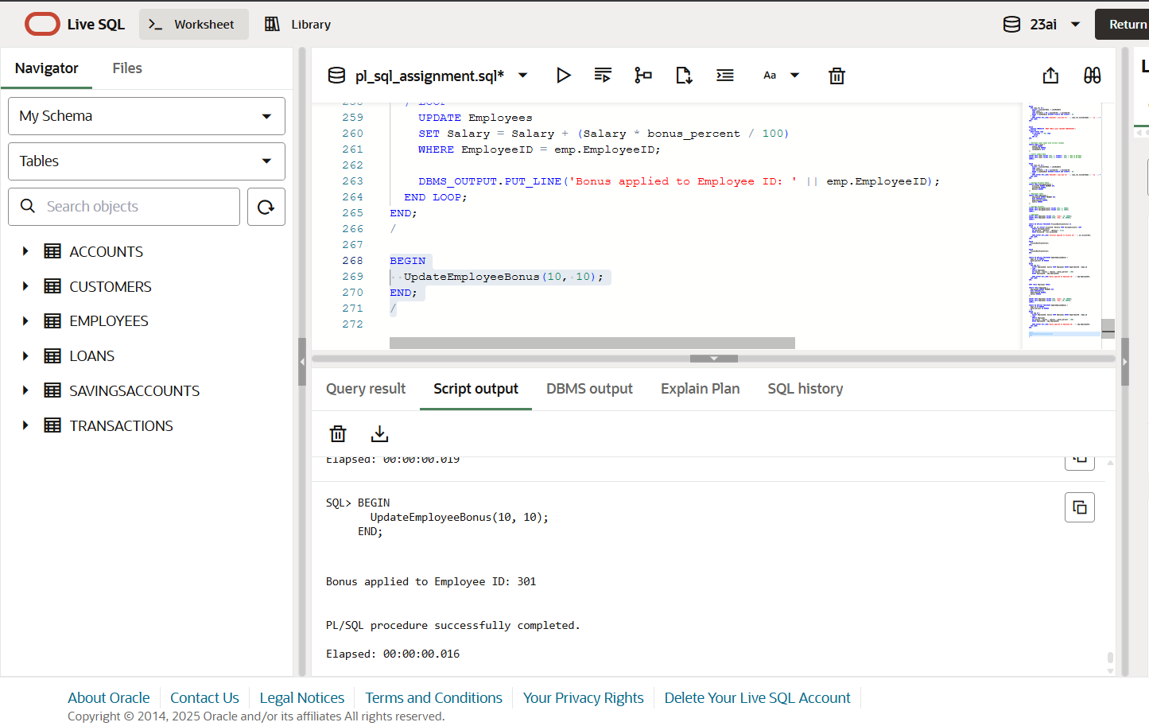  
  
Scenario 3:**

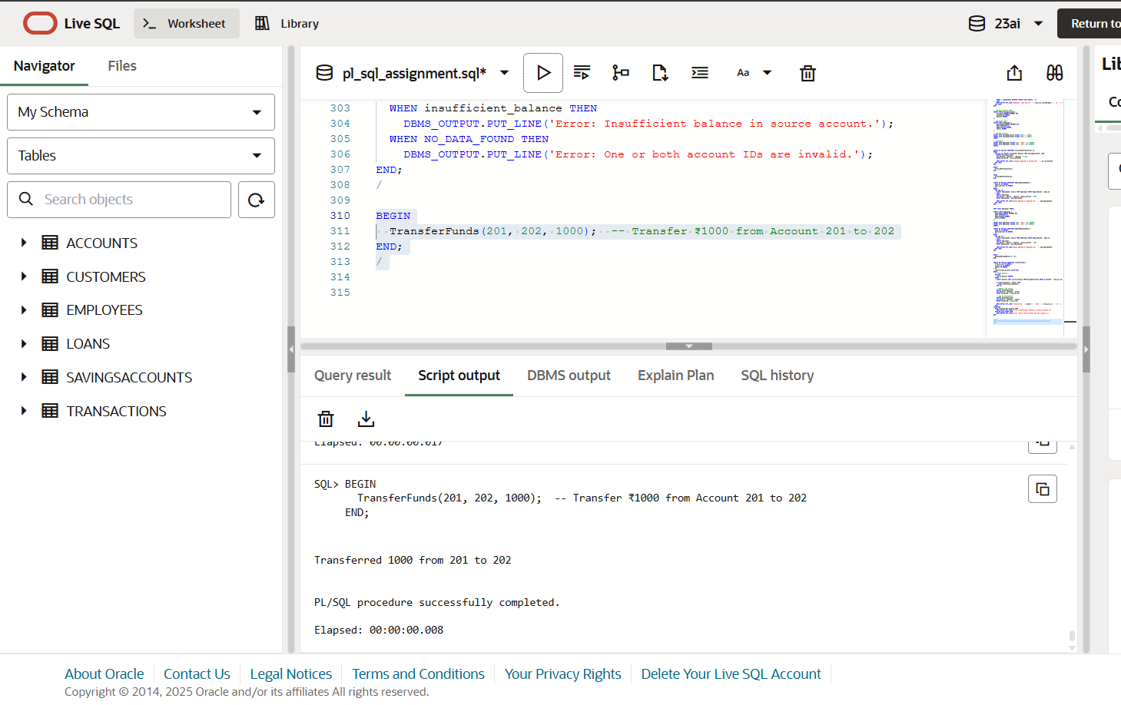

Exercise 1: Setting Up Junit  
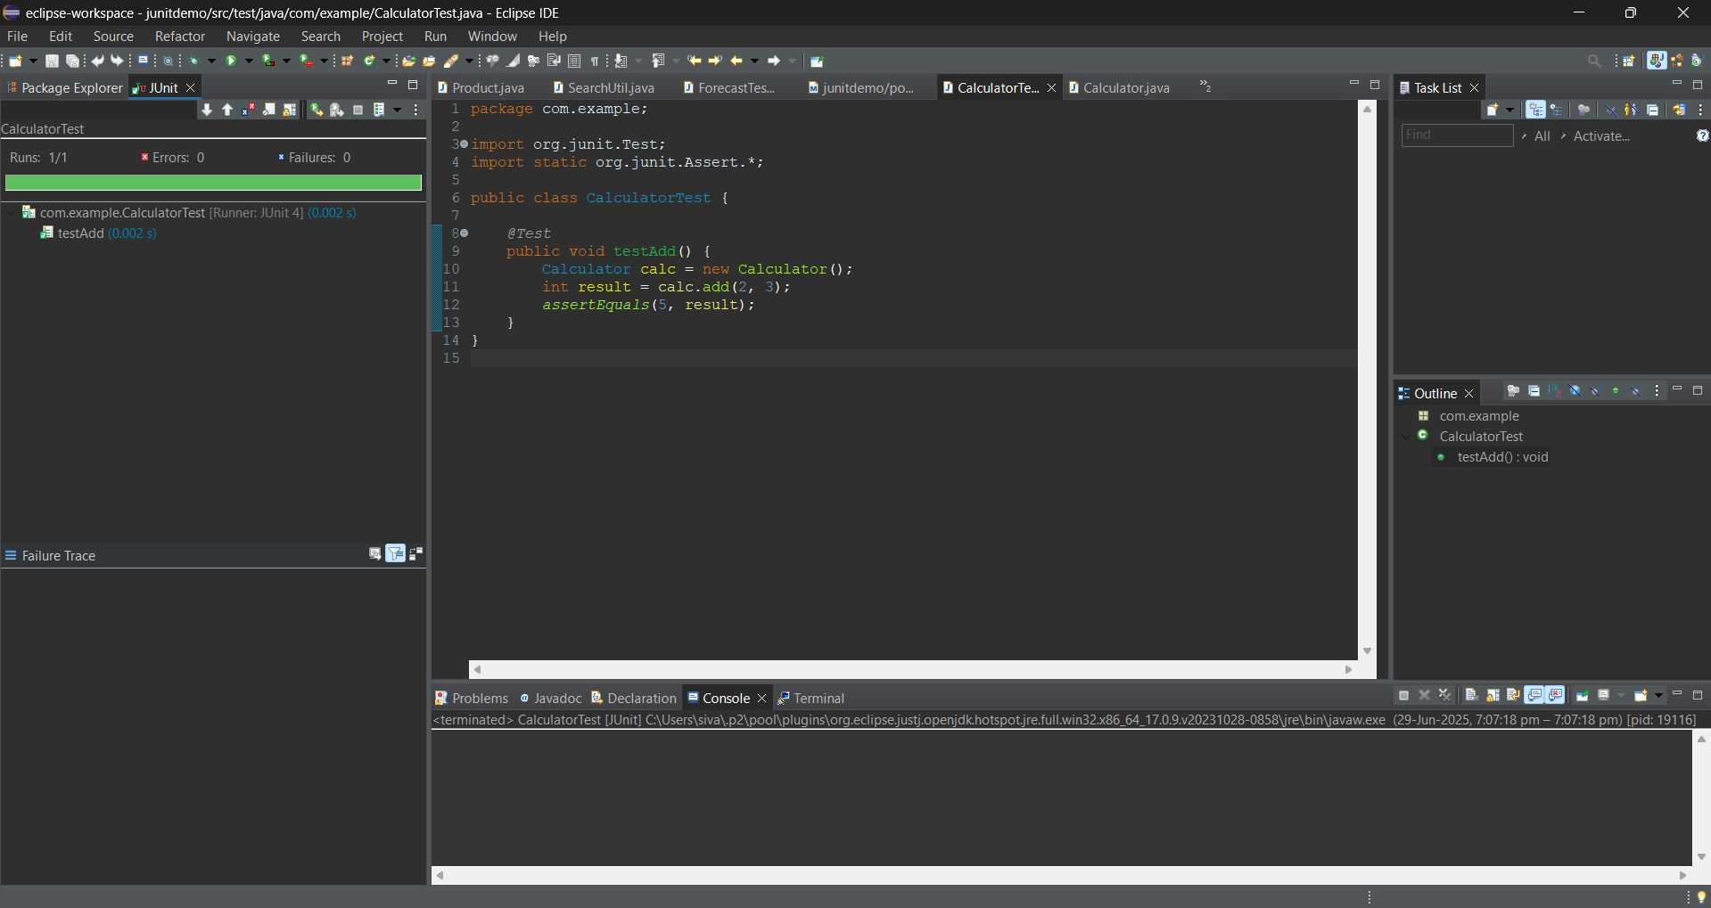

Exercise 4: Arrange-Act-Assert (AAA) Pattern, Test Fixtures, Setup and

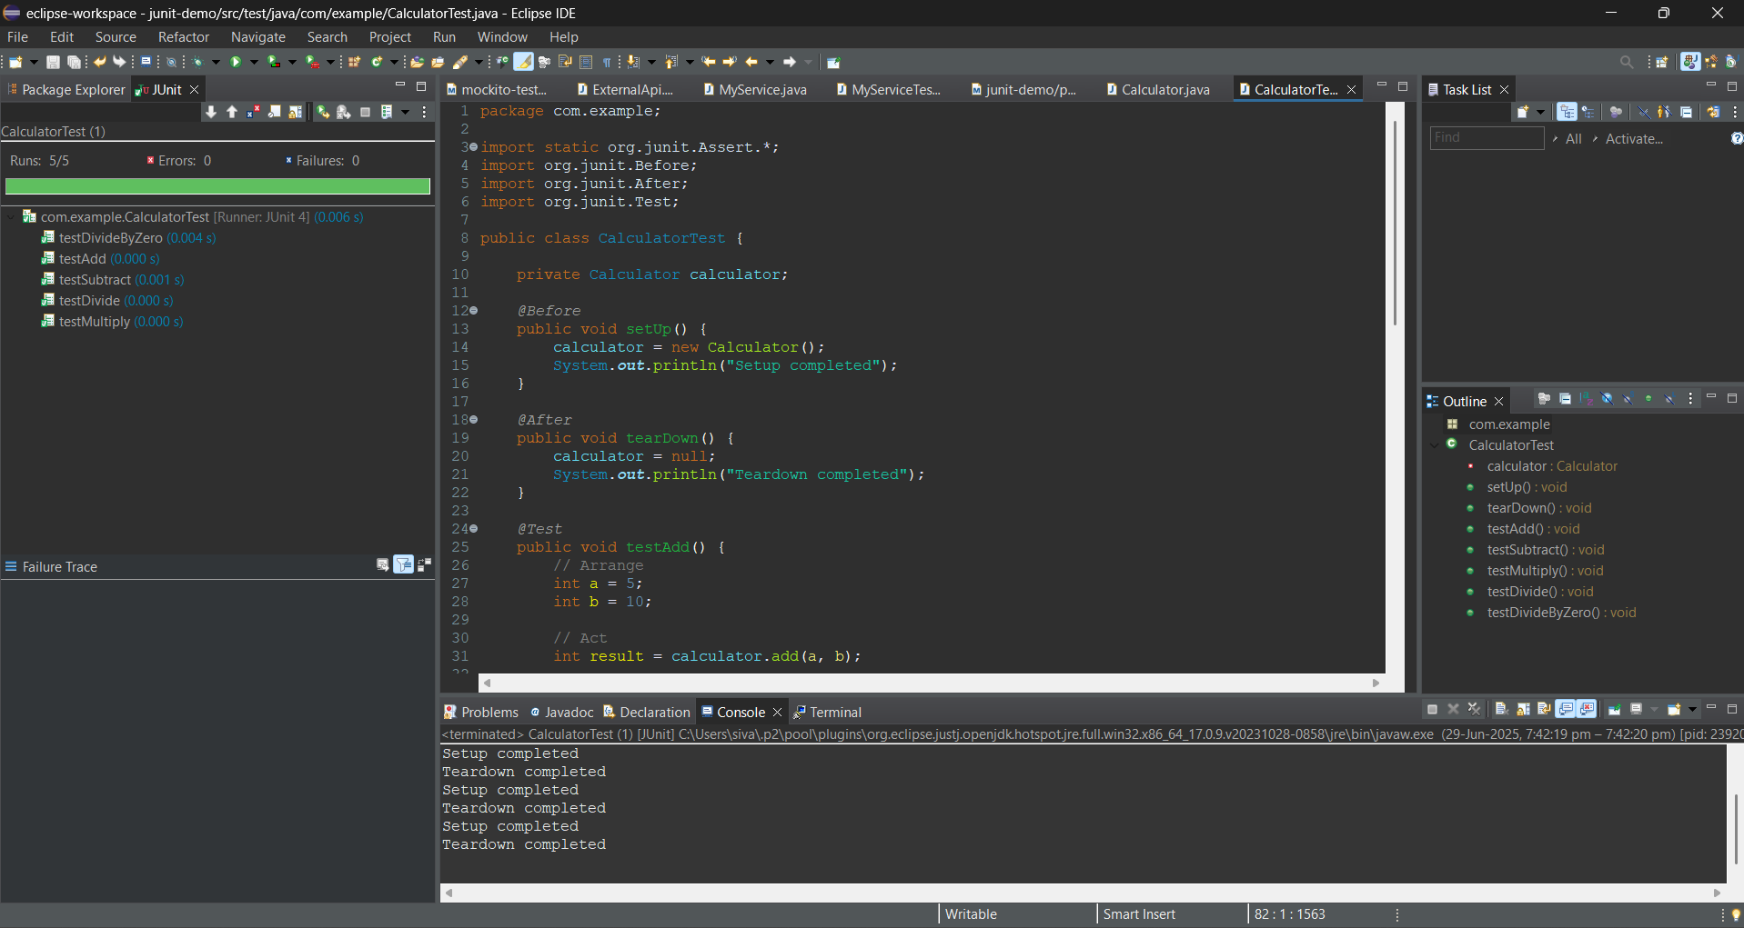

Exercise 1: Mocking and Stubbing

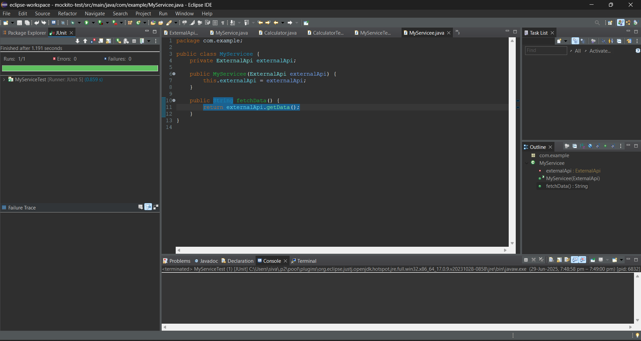

Exercise 2: Verifying Interactions

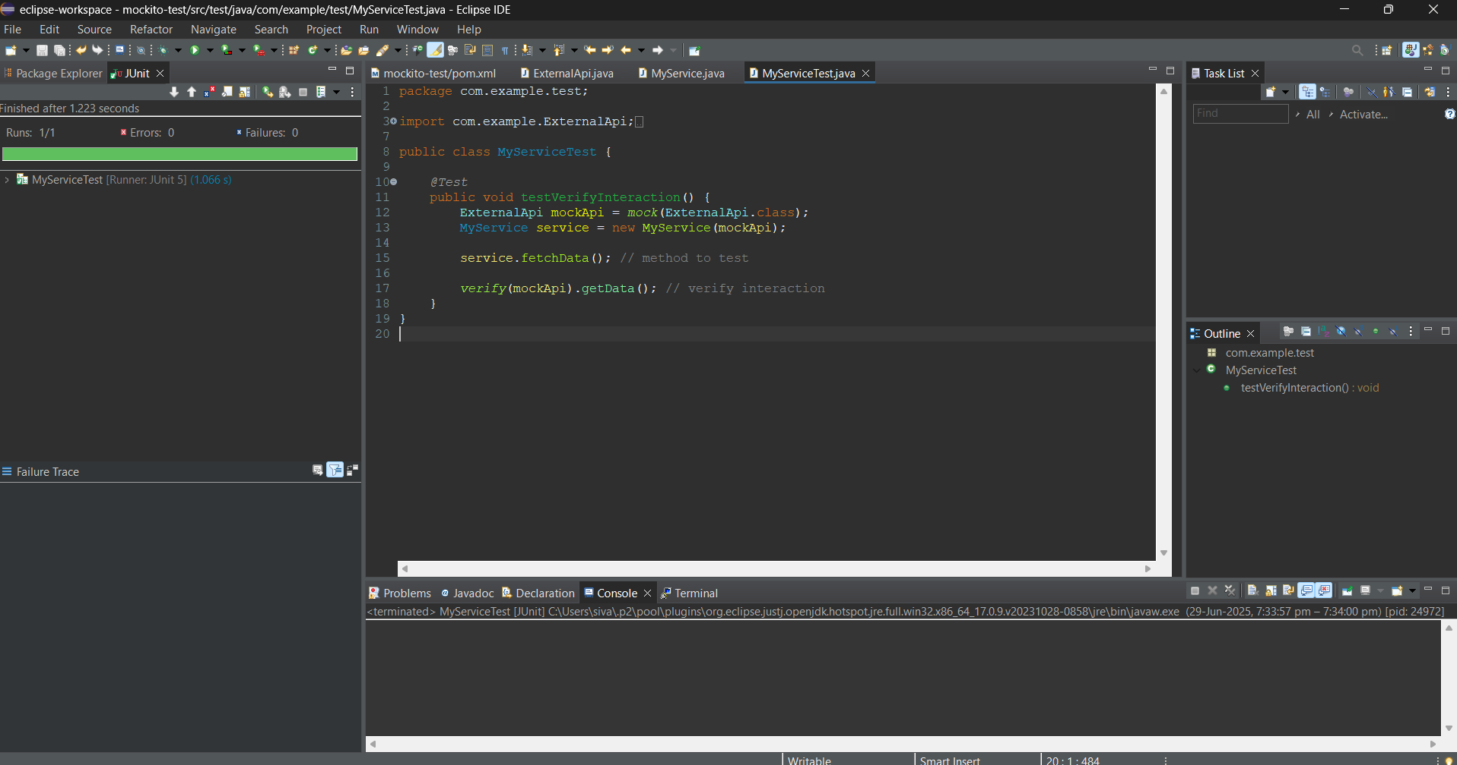

Exercise 1: Logging Error Messages and Warning Levels